ASSIGNMENT 5

OSYS1200 – Introduction to Windows Administration

NSCC

Ricardo Oliveira

W0428722

Index

Introduction 2

Question or Research Section 2

Assignment questions 2

Works Cited 4

Script used in assignment 4

ICACLS Report/Screenshot 5

PDF of Change management 6

# Introduction

The purpose of this document is to answer any questions asked in the assignment as well as a means to display your change management log and any attachments or screenshots as required.

# Permissions Calculation Table

|  |  |  |  |  |
| --- | --- | --- | --- | --- |
| **Folder** | **User or Group** | **NTFS Permissions** | **Share Permissions** | **Effective Permissions** |
| Management Folder | Management Group | Modify | Full Control | Modify |
| Sales Group | Read | Read | Read |
| Marketing Group | Read+Execute | Read | Read |
|  |  |  |  |  |
| Marketing Folder | Management Group | Read+Write | Full Control | Read+Write |
| Sales Group | Read+Write | Read | Read |
| Marketing Group | Modify | Change | Modify |
|  |  |  |  |  |
| Sales Folder | Management Group | Read+Write | Full Control | Read+Write |
| Sales Group | Modify | Change | Change |
| Marketing Group | Read+Write | Read | Read |
|  |  |  |  |  |
| Ad Campaign Folder | Management Group | Read+Write | Full Control | Read+Write |
| Sales Group | Read | Change | Read |
| Marketing Group | Modify | Read | Read |
|  |  |  |  |  |
| Collateral Folder | Management Group | Read+Write | Full Control | Read+Write |
| Sales Group | Read | Change | Read |
| Marketing Group | Modify | Read | Read |
|  |  |  |  |  |
| Quarterly Folder | Management Group | Read+Write | Full Control | Read+Write |
| Sales Group | Modify | Read | Read |
| Marketing Group | Read+Write | Change | Read+Write |
|  |  |  |  |  |

# 

# PowerShell Reports -

#Created On: 10/24/2019

#Author: Ricardo Oliveira

# *NTFS*

*Path : Microsoft.PowerShell.Core\FileSystem::E:\CompanyInc\Management*

*Owner : WS01D315\ROliveira*

*Group : WS01D315\None*

*Access : WS01D315\Sales Allow Read, Synchronize*

*WS01D315\Marketing Allow ReadAndExecute, Synchronize*

*WS01D315\Management Allow Modify, Synchronize*

*BUILTIN\Administrators Allow FullControl*

*BUILTIN\Administrators Allow 268435456*

*NT AUTHORITY\SYSTEM Allow FullControl*

*NT AUTHORITY\SYSTEM Allow 268435456*

*NT AUTHORITY\Authenticated Users Allow Modify, Synchronize*

*NT AUTHORITY\Authenticated Users Allow -536805376*

*BUILTIN\Users Allow ReadAndExecute, Synchronize*

*BUILTIN\Users Allow -1610612736*

*Audit :*

*Sddl : O:S-1-5-21-2820154595-1976357596-3937115071-1001G:S-1-5-21-2820154595-1976357596-3937115071-513D:AI(A;OICI;FR;;;S-1-5-21-2820154595-1976357596-3937115071-1002)(A;OICI;0x1*

*200a9;;;S-1-5-21-2820154595-1976357596-3937115071-1003)(A;OICI;0x1301bf;;;S-1-5-21-2820154595-1976357596-3937115071-1004)(A;ID;FA;;;BA)(A;OICIIOID;GA;;;BA)(A;ID;FA;;;SY)(*

*A;OICIIOID;GA;;;SY)(A;ID;0x1301bf;;;AU)(A;OICIIOID;SDGXGWGR;;;AU)(A;ID;0x1200a9;;;BU)(A;OICIIOID;GXGR;;;BU)*

*Path : Microsoft.PowerShell.Core\FileSystem::E:\CompanyInc\Marketing*

*Owner : WS01D315\ROliveira*

*Group : WS01D315\None*

*Access : WS01D315\Sales Allow Write, Read, Synchronize*

*WS01D315\Marketing Allow Modify, Synchronize*

*WS01D315\Management Allow Write, Read, Synchronize*

*BUILTIN\Administrators Allow FullControl*

*BUILTIN\Administrators Allow 268435456*

*NT AUTHORITY\SYSTEM Allow FullControl*

*NT AUTHORITY\SYSTEM Allow 268435456*

*NT AUTHORITY\Authenticated Users Allow Modify, Synchronize*

*NT AUTHORITY\Authenticated Users Allow -536805376*

*BUILTIN\Users Allow ReadAndExecute, Synchronize*

*BUILTIN\Users Allow -1610612736*

*Audit :*

*Sddl : O:S-1-5-21-2820154595-1976357596-3937115071-1001G:S-1-5-21-2820154595-1976357596-3937115071-513D:AI(A;OICI;0x12019f;;;S-1-5-21-2820154595-1976357596-3937115071-1002)(A;OI*

*CI;0x1301bf;;;S-1-5-21-2820154595-1976357596-3937115071-1003)(A;OICI;0x12019f;;;S-1-5-21-2820154595-1976357596-3937115071-1004)(A;ID;FA;;;BA)(A;OICIIOID;GA;;;BA)(A;ID;FA;*

*;;SY)(A;OICIIOID;GA;;;SY)(A;ID;0x1301bf;;;AU)(A;OICIIOID;SDGXGWGR;;;AU)(A;ID;0x1200a9;;;BU)(A;OICIIOID;GXGR;;;BU)*

*Path : Microsoft.PowerShell.Core\FileSystem::E:\CompanyInc\Sales*

*Owner : WS01D315\ROliveira*

*Group : WS01D315\None*

*Access : WS01D315\Sales Allow Modify, Synchronize*

*WS01D315\Marketing Allow Write, Read, Synchronize*

*WS01D315\Management Allow Write, Read, Synchronize*

*BUILTIN\Administrators Allow FullControl*

*BUILTIN\Administrators Allow 268435456*

*NT AUTHORITY\SYSTEM Allow FullControl*

*NT AUTHORITY\SYSTEM Allow 268435456*

*NT AUTHORITY\Authenticated Users Allow Modify, Synchronize*

*NT AUTHORITY\Authenticated Users Allow -536805376*

*BUILTIN\Users Allow ReadAndExecute, Synchronize*

*BUILTIN\Users Allow -1610612736*

*Audit :*

*Sddl : O:S-1-5-21-2820154595-1976357596-3937115071-1001G:S-1-5-21-2820154595-1976357596-3937115071-513D:AI(A;OICI;0x1301bf;;;S-1-5-21-2820154595-1976357596-3937115071-1002)(A;OI*

*CI;0x12019f;;;S-1-5-21-2820154595-1976357596-3937115071-1003)(A;OICI;0x12019f;;;S-1-5-21-2820154595-1976357596-3937115071-1004)(A;ID;FA;;;BA)(A;OICIIOID;GA;;;BA)(A;ID;FA;*

*;;SY)(A;OICIIOID;GA;;;SY)(A;ID;0x1301bf;;;AU)(A;OICIIOID;SDGXGWGR;;;AU)(A;ID;0x1200a9;;;BU)(A;OICIIOID;GXGR;;;BU)*

## 

## Share

Name : Marketing$

ScopeName : *

AccountName : WS01D315\Management

AccessControlType : Allow

AccessRight : Full

Name : Marketing$

ScopeName : *

AccountName : WS01D315\Marketing

AccessControlType : Allow

AccessRight : Change

Name : Marketing$

ScopeName : *

AccountName : WS01D315\Sales

AccessControlType : Allow

AccessRight : Read

Name : Management$

ScopeName : *

AccountName : WS01D315\Management

AccessControlType : Allow

AccessRight : Full

Name : Management$

ScopeName : *

AccountName : WS01D315\Marketing

AccessControlType : Allow

AccessRight : Read

Name : Management$

ScopeName : *

AccountName : WS01D315\Sales

AccessControlType : Allow

AccessRight : Read

Name : Sales$

ScopeName : *

AccountName : WS01D315\Sales

AccessControlType : Allow

AccessRight : Change

Name : Sales$

ScopeName : *

AccountName : WS01D315\Marketing

AccessControlType : Allow

AccessRight : Read

Name : Sales$

ScopeName : *

AccountName : WS01D315\Management

AccessControlType : Allow

AccessRight : Full

# Task 2 QUESTIONS

1. What is a Print Spooler and how does it work?

A: It manages the access to the printers, works generating jobs for the printers and permits the users to keep using the printers without waiting for a printing job to finish.

1. Explain “how a document page gets from your computer to the printer on the other side of the room?”

A: The user click on the printer icon, choose the printer, the specifications, and send that print job, that gets sent to the printer server spooler and get ordered with the other jobs and gets printed according to the availability

# Change management

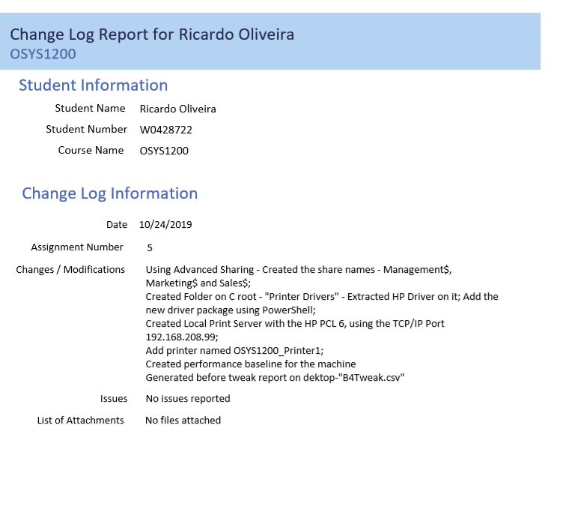

# Performance Monitor

